Meeting Agenda (1/16/21) – MCSA Midwinter’s Meeting

Meeting Information
Date: January 16th, 2021 Location: https://umich.zoom.us/j/92892941713
Time: 1200 - Roll Call Meeting Type: MCSA Midwinters Meeting
1400- Adjournment
Called By: Brian Tobelmann Facilitator: Brian Tobelmann
Timekeeper: Minutes By: Brian Tobelmann
Expected Attendance:
Representatives from the following teams: WISCO, MICH, NWU, ND, UMN, WMU, OSU, MRQ, MUO, MSU, GVSU, PUR, HOP, OU, IU, ILL, BWU, UWM, HILL, CHI, TOL, ISU, MTU, NMU, SMC, JCU, UNL, CSU, CAR, LFC, IOWA, WSH, MSU

Board Members: Brian, Nicole, Mason, Bobby, Elisabeth, Tye, Erin, Susahha, Thomas

Attendance: WISCO, MICH, NWU, ND, WMU, OSU, MRW, MUO, GVSU, PUR, HOP, OU, IU, BWU, HILL, TOL, MTU, NMU, JCU, CSU, IOWA, WSH, Brian, Bobby, Elisabeth, MSU, Susannah, Mason,
Absence: UMN, ILL, UWM, CHI, ISU, SMC, UNL, CAR, LFC, Nicole, Tye, Erin, Thomas

Agenda
- Call to Order (Brian)
- Roll Call (Brian)
- Approval of 2020 Midwinters Minutes
  - Wisco motion to approve, Indiana second, passed unanimously
- Updates from Board
  - Commissioner (Brian)
    - Approval of By-law changes
      - Brian motions to pass unanimous consent of By-law changes, Wisco seconds, Toledo Abstains, unanimous consent fails
      - Article 4, Section 1A: Wisco motions, Marquette seconds, Passed unanimously
      - Article 4, Section 1B: Miami motions, Marquette seconds, passed unanimously
      - Article 4, Section 1C: Wisco motions, Marquette seconds, passed unanimously
      - Article 5, section 1A: Wisco motions, Marquette seconds, passed unanimously
      - Article 5, section 1B: Wisco motions, Marquette seconds, passed unanimously
      - Article 5, section 1C: Wisco motions, Marquette seconds, passed unanimously
      - Article 5, section 1D: Wisco motion, marquette seconds, passed unanimously
      - Article 5, section 2B: Wisco motion, marquette seconds, passed unanimously
      - Article 7, Item C: Wisco motion, Marquette seconds, passed unanimously
      - Article 7, item D: Wisco motion, Marquette seconds, passed unanimously
      - Article 7, section I: Wisco motion, Marquette second, passed unanimously
        - Wisco motions to amend motion to include change in title of coordinator, marquette seconds, passed unanimously
      - Article 7, section 2a(ii): wisco motion, Marquette seconds, passed unanimously
      - Article 7, section 2a(iii): wisco motion, Marquette second, passed unanimously
      - Article 14, section 3a: wisco motion, Marquette second, passed unanimously
      - Article 18: wisco motion, marquette second, passed unanimously
    - Review of Policy Changes
    - New elections will be effective 2/7
  - Interconference (Mason)
    - No updates, no sailing this year
  - Commodore (Bobby)
    - No updates, unfortunate year, hopefully get sailing in spring
  - Vice-Commodore (Elisabeth)
    - No new teams but tough with pandemic
  - Race Chair (Tye)
    - No regattas, no updates
  - Publicity Chair (Erin)
    - Working on apparel for MCSA and uploaded photos to Flickr
  - Interteam (Susannah)
    - No updates, promising to spread sailing knowledge
  - Clinic (Thomas)
    - Not present
- Treasurer’s Report (Nicole)
  - Didn’t assess dues to any teams in 2020, we had enough cash on hand to cover ICSA dues which depleted cash on hand.
  - Brian proposes a $150 one-time assessment to replenish cash and cover a portion of their 2020 ICSA dues
- Foundation Report (George)
  - Not present
- Proposals from Executive Board:
  - Approval of new members
  - Termination of Members
  - Confirmation of ICSA Representatives
    - 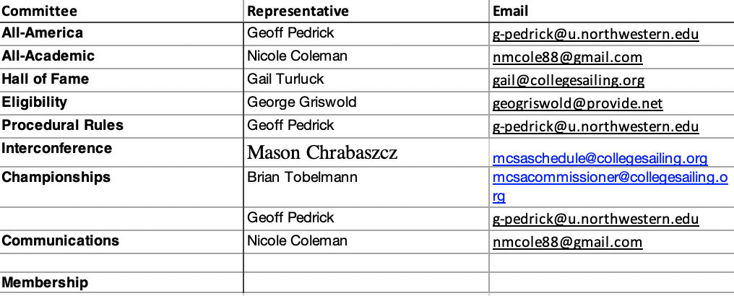
- Proposals from the Floor
  - No MCSA schools available on techscore selection
  - Contact Gail for alumni information
  - LMSRF grants available for teams in the region
  - Seek out funding from foundation if the 2020 ICSA dues are burdensome
- Election of Officers (https://forms.gle/pkgJLtHiDZ1iBcay6):
  - Commodore
    - Elisabeth Johanson (Wisco)
    - Brian Pribe (Toledo)
  - Vice Commodore
    - Grace Goszkowicz (Hope)
  - Race Chair
    - Samuel Bartel (Wisco)
    - Chase Ireland (withdrawn)
  - Publicity chair
    - Joe Kenealy (Cleveland State)
    - Eva Rossell (MSU)
  - Clinic Coordinator
    - Avery Lawrence (OSU)
    - Christiana Scheibner (Michigan)
  - Interteam Coordinator
    - John Alexis (Indiana)
    - Susannah Schroeder (Miami)
  - Commissioner
    - Craig Mueller (Toledo ’19)
    - Libby Reeg (Hope ’17)
    - Olivia Staruck (Wisco ’20)
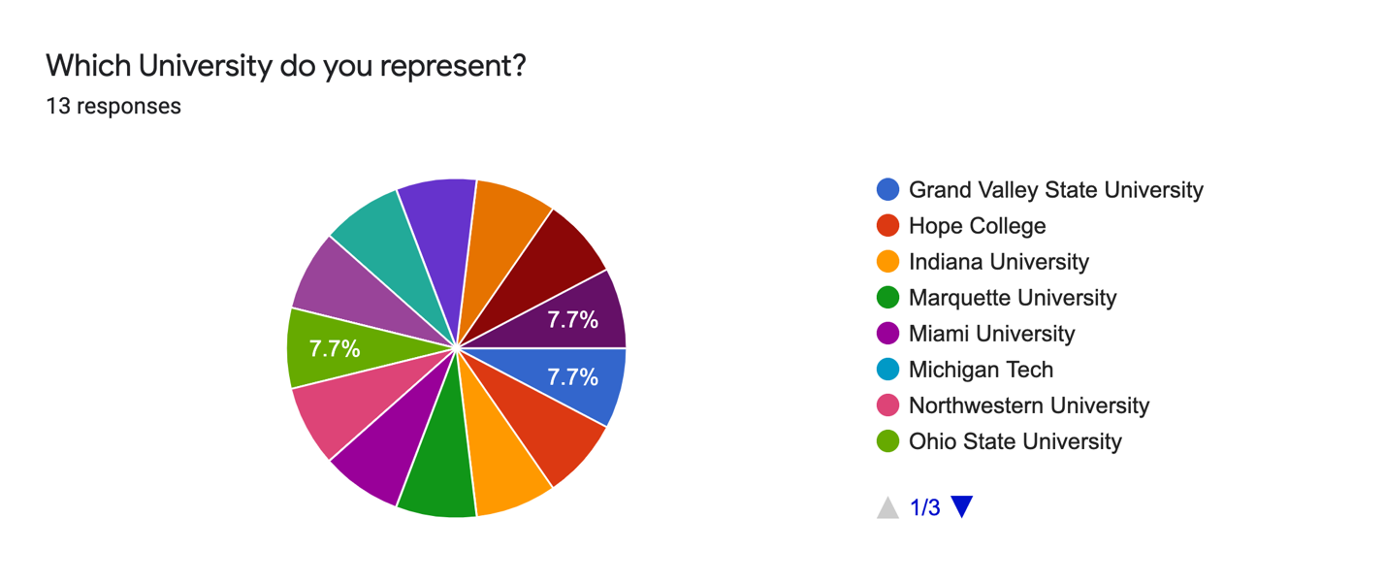
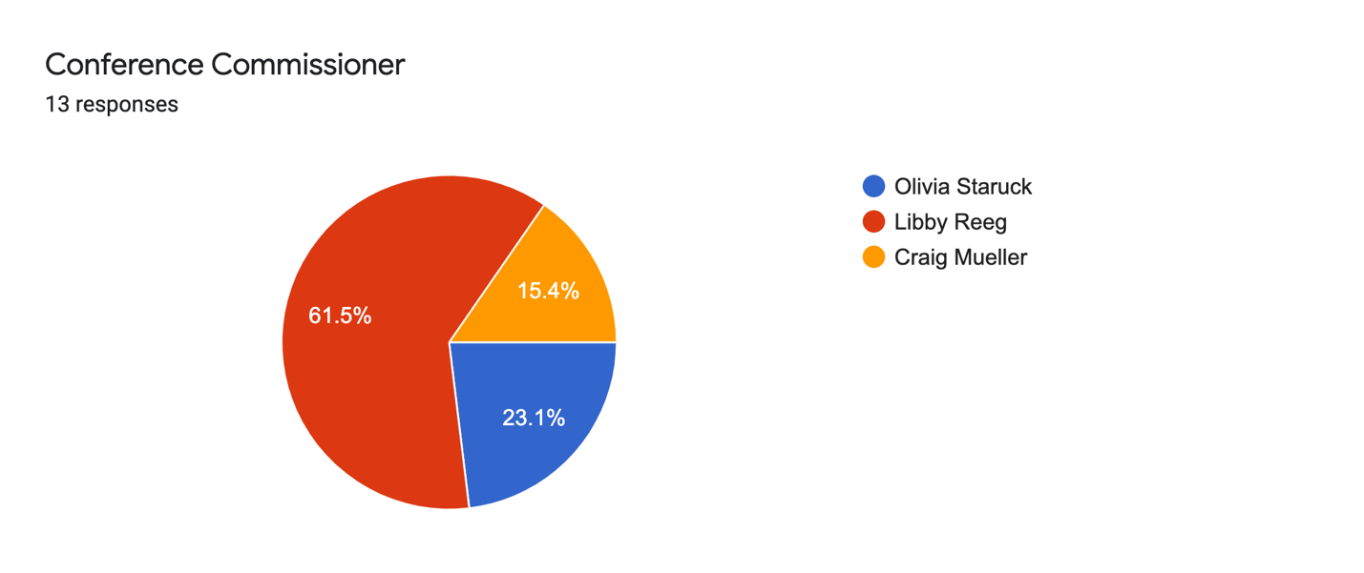
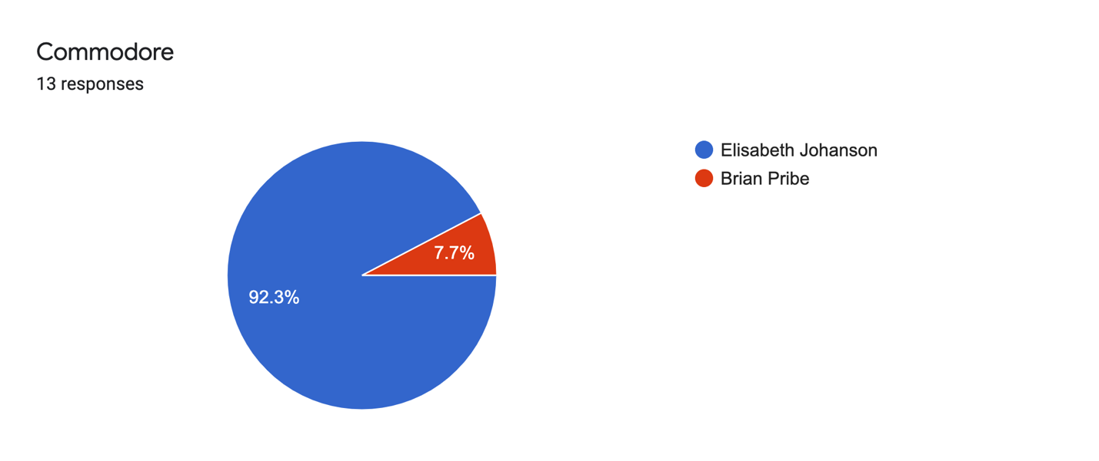
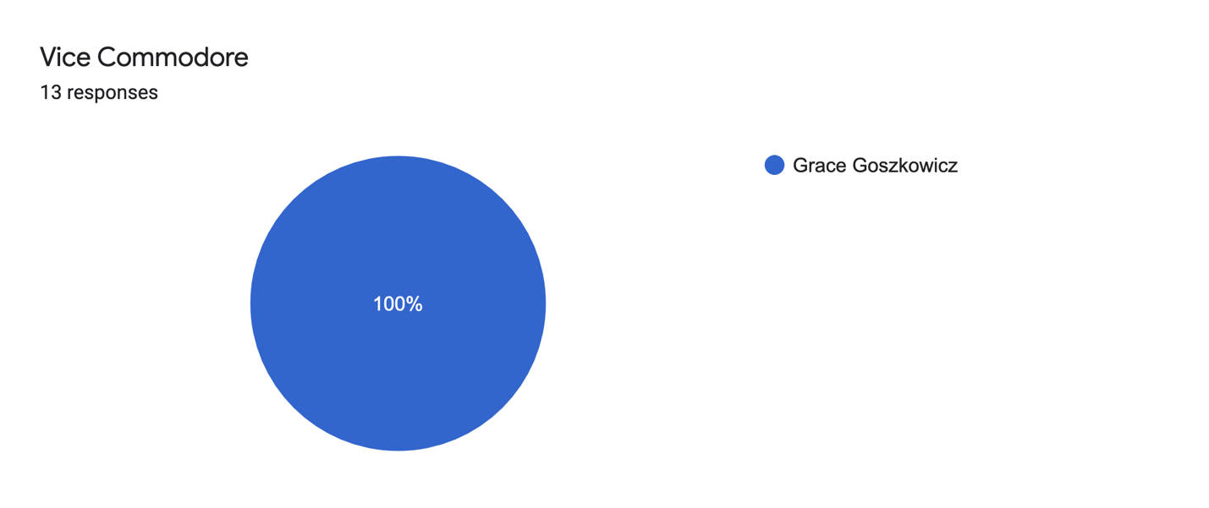
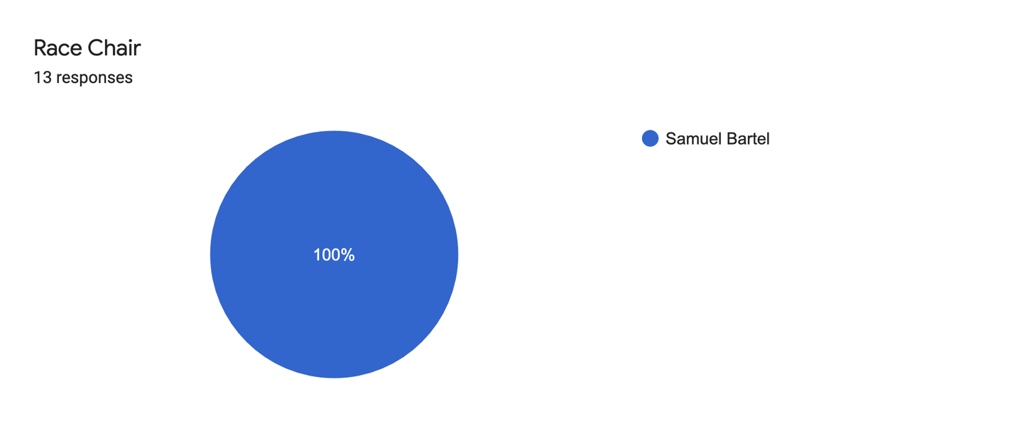
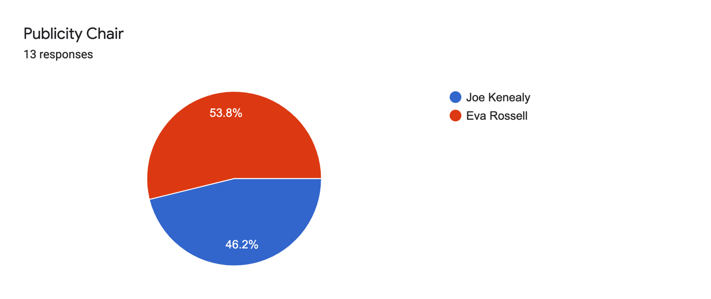
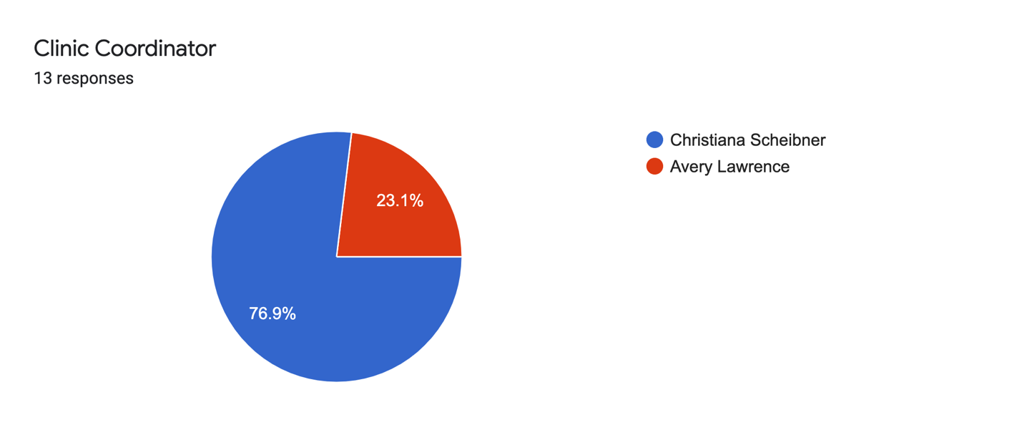
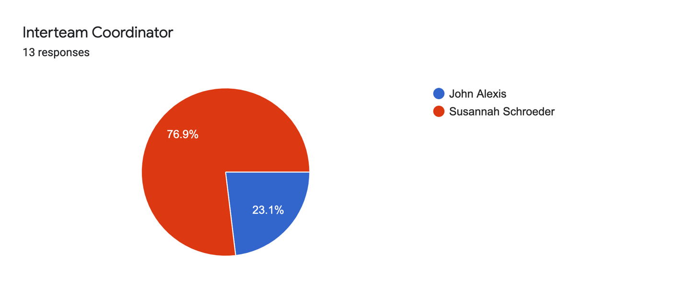
- Installation of new Board
- Adjournment

